Spirit of Speed
Marketing Document

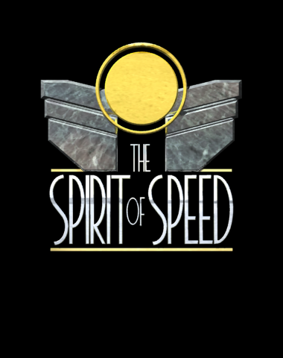Introduction

One of the best selling genres in the video game market today is Motor Car racing, either as Rally style or Racetrack style.

In the Racetrack format there is the closed saloon style (Touring Cars) and open style (Formula 1). The market is currently swamped with Formula 1 titles, with at least 5 on the market before Christmas 1998. The only original title out now is Grand Prix Legends from Sierra.

Grand Prix Legends (GPL) has had an extensive promotional campaign extolling the virtues of racing in 1967, a time before cars and racing became safe and predictable. The media has taken this idea to heart, and GPL has become one of the most eagerly awaited titles of the autumn. The fact that the game is set over 30 years ago has not had a detrimental effect on the media anticipation; in fact the opposite is true.

Cars back then had low tyre grip, and lots of power. They didn’t go round the circuit like they were on rails, they power slid round corners with four wheel drifts the norm not the exception. Safety for drivers was not a concern either for the drivers or the public at large. Big accidents means big spectacle.

Spirit of Speed is set in the period between 1920 and 1939 before cars became set to a formula. The cars had even less grip than the cars in GPL and with engines ranging from below 1 litre to above 24 litres the variation in racing techniques was vast. The circuits raced on, unlike those in both GPL and modern racing simulations, had enormous variation, from road circuits and circuits like today’s, to purpose built banked tracks like Brooklands. And whereas today racing can quickly become processional, in Spirit of Speed with all classes of cars competing on a handicap basis, the excitement of overtaking and being overtaken continues to happen throughout the race.
Comparison of Grand Prix Legends and Spirit of Speed

GPL appears to be based on a fairly basic 3D polygon engine, with no lighting effects other than Gouraud shading and a fairly low polygon count. The shadows under the cars are model based, and do not change as the car bounces in the air. There are no effects that address the techniques that are expected on a modern engine, i.e. environment mapping, directional lighting, real time shadows, bump mapping and detail mapping.

With 3D cards like Voodoo2, Riva TNT and Matrox G200 on the market now, and more powerful cards available next year, the market expects all these techniques. The Broadsword engine provides all these and more.

The only graphics cards supported by GPL are the Voodoo and Rendition based cards. This prevents people with high end machines and the latest cards, or even any card produced this year, from running the game in anything but the software renderer. The Broadsword graphics engine, BORIS, supports both Direct3D and Native methods for final rendering, and as such supports not only any card on the market today, but also those not yet announced. This also opens up possibilities of OEM deals.

BORIS, unlike most racing engines is fully world based, not strip based. Problems with strip based engines can be seen in GPL with the replay cameras. If the cars move off the track, holes can be seen in the world. This does not happen with BORIS.

Sound is an increasingly important part of any game, with 3D sound and Environmental audio for added realism. BORIS supports 3D sound using DirectSound3D and uses Creative Lab’s EAX extensions to provide effects like canyon reverb and echo. GPL has standard 4 channel sound.

Unique Selling Points for Spirit of Speed.

- The first racing game set in the dangerous and exciting pre-war racing era.
- Developed with the support of the Brooklands Society and the Brooklands Museum.
- 12 Highly detailed tracks from Brooklands in the UK, Avus in Germany, Tripoli in Libya to Roosevelt in the USA.
- Highly accurate physics modelling provides accurate collision realistic handling allowing power slides and 4-wheel drift. If oil gets spilled on the track, cars will react to it during the game.
- Car models that react to collision by showing damage.
- More than 30 original and varied cars, from under 1 litre to over 24 litres.
- State of the art 3D graphics engine with environment mapping, real-time shadows, bump mapping and detail mapping, scalable from Pentium 200 MMX upwards.
- Highly intelligent and realistic AI allows opponents cars to not only race accurately, but with unique driver characteristics, to have as much difficulty as you do in controlling the cars.
- Lighting effects such as exhaust smoke, tyre smoke, engine flames etc.
- Environmental 3D Sounds.
- Up to 16 networked players.
- The BORIS engine will be used in future Broadsword products.

